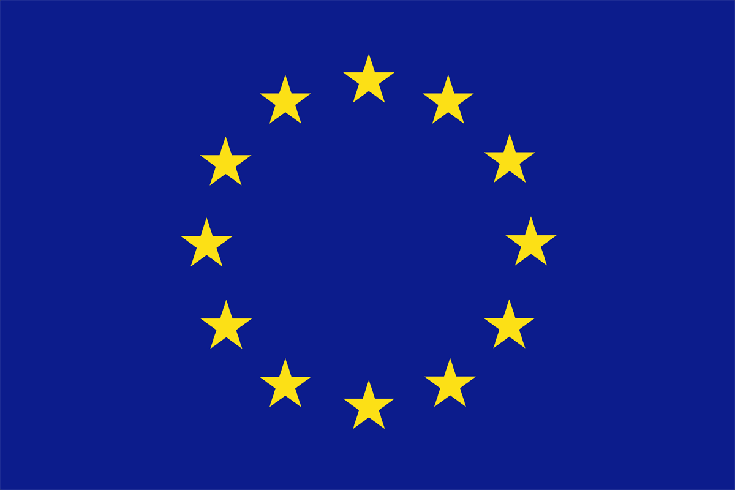

Final conference
INTERPOL headquarters
270 Quai Charles de Gaulle
Lyon, 25-26 June 2015

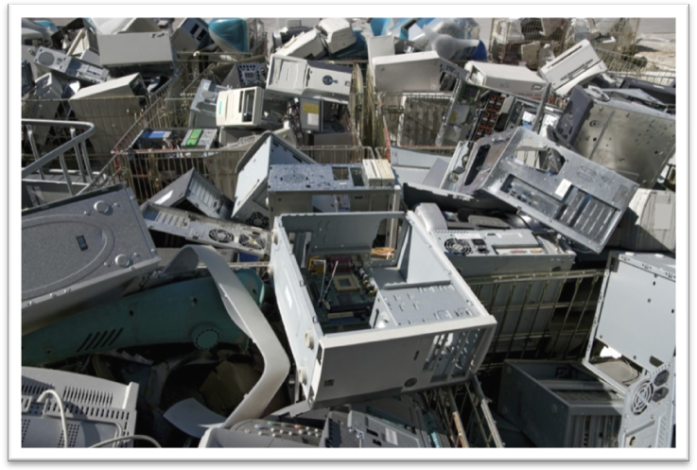

Day One – Thursday 25 June 2015
09.00 – 10.00 | Registration and coffee
10.00 – 10.20 | Opening remarks | Tim Morris and David Higgins – INTERPOL  Maria Banti on behalf of Markus Müller–European Commission
10.20 – 10.40 | Keynote address | Juliette Kohler on behalf of Rolph Antoine Payet – Rotterdam, Stockholm and Basel Convention  David Jordan – Environment Agency England (UK)
10.40 – 11.30 | CWIT key findings and recommendations | Jaco Huisman– UNU  Ioana Botezatu – INTERPOL  Juha Hintsa – CBRA  Pascal Leroy – WEEE Forum
11.30 – 11.45 | Coffee Break
11.45 – 13.00 | Topic I  Collect more, prevent leakage  (Including Q&A) | Chair: Norbert Zonneveld** – EERA  Speaker: Sébastien Partida – Eco-systèmes (FR)  Chris Slijkhuis – Müller Gutenbrunn (AT)  Per Knut Vistad – Politiet (NO)  Lucía Herreras– WEEEForum
13.00 – 14.30 | Lunchand film “The E-Waste Tragedy”, directed by Cosima Dannoritzer *
14.30 – 15.45 | Topic II  Trading, treatment and the economics behind criminal behaviour  (Including Q&A) | Chair: Katie Olley**– Scottish Environment Protection Agency  Speaker: Christopher Smith– Environment Agency England (UK)  Huib van Westen – Inspectie Leefomgeving en Transport (NL)  Mike Anane – Freelance journalist (GH)  Jim Puckett – Basel Action Network (US)  Bogdan Ghenciu – INTERPOL
15.45 – 16.00 | Group photograph at the atrium
16.00 – 16.30 | Coffee break
16.30 – 17.45 | Topic III  Robust and uniform legal framework, implementation and enforcement  (Including Q&A) | Chair: Juliette Kohler** – Basel Convention Secretariat  Speaker: Bogdan Haiducu– Unităţii Centrale de Analiză a Informaţiilor, Ministry Internal Affairs (RO)  Marc Clément – Cour administrative d’appel de Lyon (FR)  Katja Eman– Univerza v Mariboru (SI)  Teresa Fajardo del Castillo – EFFACE (ES)  Mary Liddane – C2P (IE)
17.45 – 18.00 | Closing remarks | Pascal Leroy – WEEE Forum
20.00 – 23.00 | Dinner
*Meet the press at 13.00.
**Member of the CWIT High Level Advisory Board

Day Two– Friday 26 June 2015
09.00 – 09.20 | Coffee
09.20 – 09.30 | Opening remarks | Pascal Leroy – WEEE Forum
09.30 – 10.45 | Topic IV  Best practices in enforcement and prosecution  (Including Q&A) | Chair: Frederik Verhasselt** – Umicore  Speaker:Jürgen Braun– Polizei Bremen (DE)  Rob de Rijck– Functional Prosecution Service (NL)  Malin Folkesson– Polisen (SE)  Jean-Philippe Rivaud – Courd’appel (FR)  Vittoria Luda di Cortemiglia– UNICRI
10.45 – 11.15 | Coffee break
11.15 – 12.45 | Topic V  CWIT 2020: Roadmap to crime free WEEE trade and a circular economy  (Including Q&A) | Chair: Stephanie Adrian** – Environment Protection Agency (US)  Speaker: Nadia Herbelot – Ministère de l’Environnement (FR)  Maria Banti – European Commission  Nancy Isarin– IMPEL  Eelco Smit** – African Alliance  Juha Hintsa – CBRA
12.45 – 13.00 | Closing remarks | Pascal Leroy – WEEE Forum  David Higgins – INTERPOL
13.00 – 14.00 | Lunch

